Progressive web app

Live URL : https://demopwa-5d6bc.firebaseapp.com/

Technology :-

fronted :- javascript html,nodejs
backed :- firebase database
external library :- firebase messanging api,notficaiton api,sync api

- How to start app ?

- go to the file location in cmd
- type “npm start” and Enter key press

- Purpose and Scope :-

Progressive Web App (PWA) is a term used to denote a new software development methodology. Unlike traditional applications, progressive web apps are a hybrid of regular web pages(or websites) and a mobile application. This new application model attempts to combine features offered by most modern browsers with the benefits of mobile experience.

1) Enable notification :-

A push notification is a message that pops up on a mobile device. App publishers can send them at any time; users don't have to be in the app or using their devices to receive them. They can do a lot of things; for example, they can show the latest sports scores, get a user to take an action, such as downloading a coupon, or let a user know about an event, such as a flash sale.

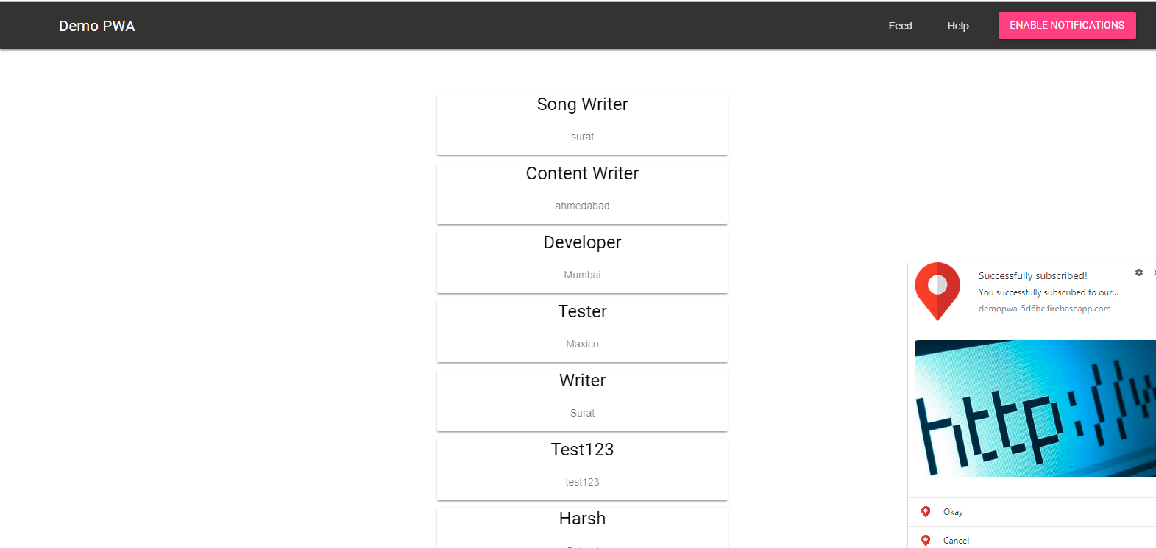

- Push notification feature is use for the give use notification on mobile
- when user add any record it will be notify using push notification

- Background sync

- The basic concept is that you can queue events within the browser that will fire in your Service Worker when the browser has network connectivity.

- The difference with Background Sync is that the event listeners will fire even if your web app isn’t open in the browser because the sync fires in a Service Worker.

- We can also add a record when we offline and it will be insert database
when network is online

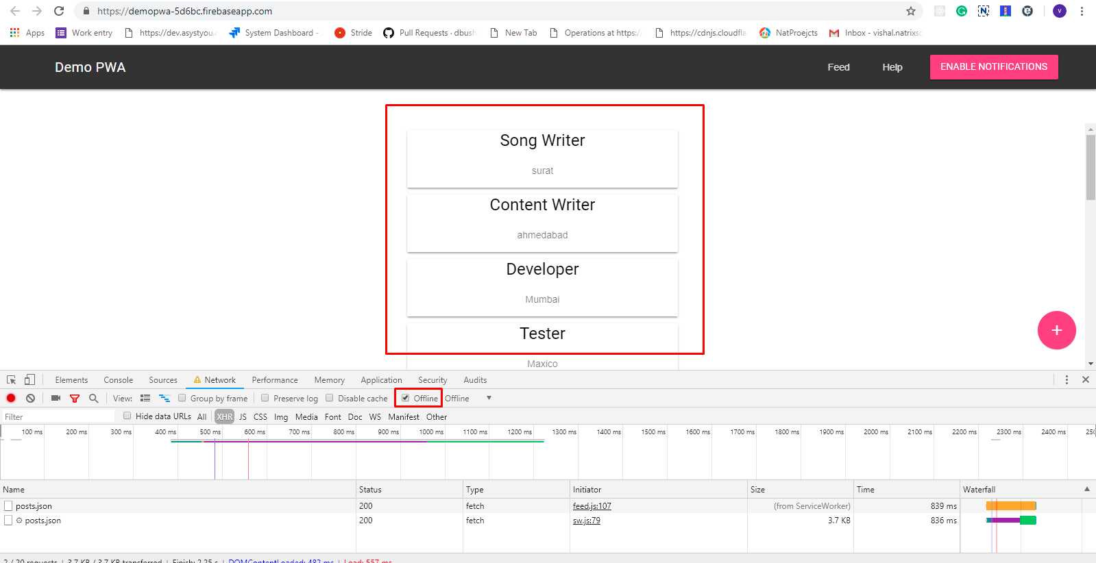

3) Why Should You Build a PWA?

- You should make your webapp into a PWA because it’ll reduce the time it takes for your app to load and it’ll give your users a better experience. Having it load over HTTPS is a good security practice and adding icons (using a web app manifest) is something you’d do anyway. Having a cache-first service worker strategy will allow your app to work offline (if the user has already loaded data), alleviating one of the biggest issues with webapps.

- There are a number of other performance recommendations you can implement in your webapp. While the following list is not required for PWAs, many PWAs employ these elements:

- Implement the PRPL pattern:

- Push critical resources for the initial URL route.

- Render initial route.

- Pre-cache remaining routes.

- Lazy-load and create remaining routes on demand.

- Use <link rel=”preload”> to tell your browser to load a resource you know you’ll eventually need. This is a W3C Standard specification.

- Use HTTP/2 and server push to “push” assets to the browser without the user having to ask for them.

- Use code-splitting and lazy-loading for granular loading of application pages/features.

